Experiment 14: Cracking the Password Using Hydra in Kali Linux
Aim
To study the Hydra tool in Kali Linux and understand password auditing using a wordlist in an authorized test environment.
Algorithm
- Start Kali Linux and open the terminal.
- Check whether Hydra is installed.
- Verify the availability of the rockyou.txt password wordlist.
- Examine Hydra's help options and supported services.
- Use a controlled lab environment to understand password auditing.
- Observe the output and record the result.
Commands
1. Check Hydra installation
hydra -h
Use: Displays Hydra's help information and command-line options.
2. Check the password wordlist
ls -l /usr/share/wordlists/rockyou.txt
Use: Verifies that the extracted password wordlist exists.
3. Display the first 10 entries
head /usr/share/wordlists/rockyou.txt
Use: Displays the first 10 lines of the wordlist.
4. View Hydra usage examples
hydra -U
Use: Displays module-specific help when supported by the installed Hydra version. If it reports that a service argument is required, use hydra -h for general help.
Sample Output
After running the wordlist verification command, you should see file information similar to:
-rw-r--r-- 1 root root ... /usr/share/wordlists/rockyou.txt
After running hydra -h, Hydra displays its usage information and available options.
Note: These are illustrative outputs; your actual output may differ.
Use of Hydra
- Hydra is a password-auditing tool.
- It supports authentication testing for various network services.
- It can use wordlists to evaluate password strength.
- It helps security professionals identify weak authentication in authorized test environments.
- 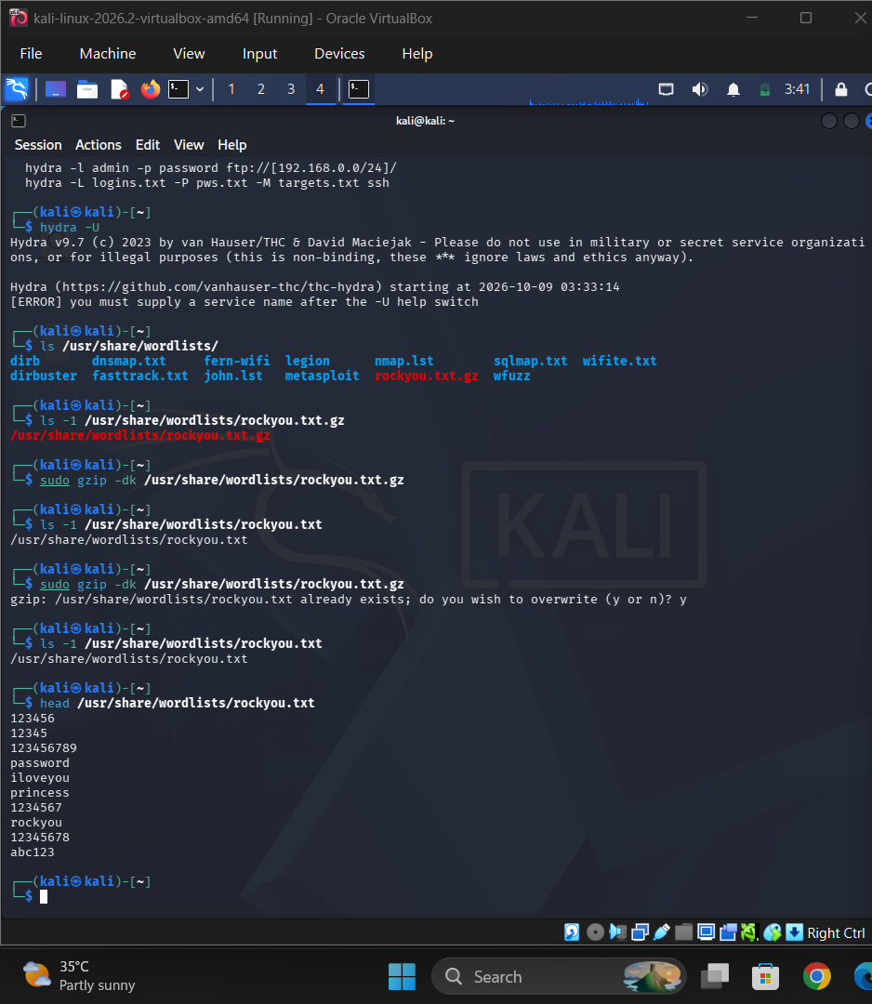

Result
Hydra was verified in Kali Linux, and the rockyou.txt wordlist was successfully extracted and checked. Hydra's help options were examined to understand its use in authorized password-security testing.

